COAL LAB MANUAL

**Submitted to:**

Dr. Tauqir

Teacher assistant : Sir Shahzad

**Submitted By:**

Komal Shehzadi

Registeration no : 2016-CS-178

**Section:**

Section B

**Department:**

Department of Computer Science

**Institute:**

University of Engineering and Technology Lahore (Main Campus)



**Date of Submission:** March 29, 2018

# LAB 2

# Task : ADDING TWO NUMBERS FROM 0 TO 9 AND SHOWING THERE SUM TILL ONE DIGIT

The description inside the “// ‘ ‘ // “ are the comments to make the code more clear. These are not the part of program.

**// PROGRAM //**

org 100h

**// taking first number from keyboard //**

mov AH, 1

INT 21h

**//saving it in BH register in its real value by subtracting it from 30 //**

mov BH, AL

sub BH, 30h

**// displaying new line and carriage return to place the cursor on the start of next line //**

mov ah, 2

mov dl, 0Ah

INT 21h

mov dl, 0Dh

INT 21h

**// taking 2nd input number from keyboard//**

mov ah, 1

INT 21h

**// saving it in BL in its original state//**

mov BL, AL

sub BL, 30h

**// Displaying a new line on screen//**

mov Ah, 2

mov DL, 0Ah

INT 21h

**// adding 2nd input placed in BL to BH//**

ADD BH, BL

**// adding 30 in result to display the decimal value //**

add BH, 30h

**// Displaying the result of sum of two digits //**

mov AH, 2

mov DL, BH

int 21h

ret

**// END //**

## Commands:

**Org 100:** Set offset of the segment originated at 100hex

**MOV:** Moves the contents of source instruction in destination and the syntax is as follows:

Mov Destination, Source

**INT 21H:** Call to DOS interrupt Handler

**Sub:** It is used to subtract destination from source and store the result of computation in destination.

Sub Destination, Source

**Add:** It is used to add source in destination and store the result of computation in destination.

Add Destination, Source

**Ret:** Return statement to end the program

## OUTPUT:

The following output screen is displayed when the above program is run 3rd digit is the sum of first and 2nd digit.

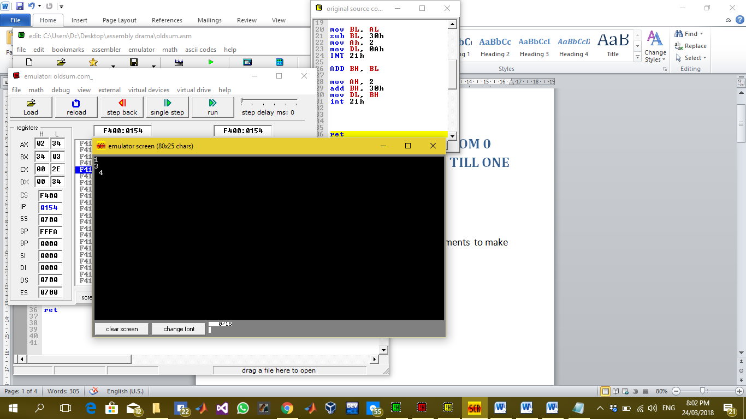

## Description:

in this lab we are adding two numbers entered from keyboard both numbers are from 0 to 9 and by adding them we can display there sum till one digit means maximum digit 9 can be displayed correctly as the sum of two digits because till now we can handle hexadecimal single digit through register so we are displaying a sum of maximum one digit value. For this purpose we have used simple interrupts to take input and display output on screen and to store the hexadecimal value in decimal state we have subtracted 30 from the value and vice versa to display the value we have added 30 in it.